IT 202 Project One Site Survey

Stakeholder Info
This section lists the project stakeholders:

Chief Information Officer: Jason Wolf

Systems Security Officer: Tom Howard

Assistant Vice President of Finance: Dennis Smith

IT Project Manager: Mike MacFarland

Systems Architect: Tamani Harrison

Operating Systems
Provide approximate number of users who currently use each OS:

Windows: 107 users

macOS: 7 users

Linux: 13 users

*If there is additional information required, such as details of the OS version or different OSes being used, include here: 6 Windows Server 2012 R2 users. 7 macOS El Capitan users. 13 Linux RedHat users. 101 Windows 7 users.

Server
Determine whether the desktops are on a hardware or cloud-based server. Also specify the version of the OS server.

Physical: The desktops are connected to a physical server. The OS server is Windows 7. The connection between all of the department desktops implies the use of a physical server.

Cloud-based: The desktops use a physical server not a cloud one.

Standard Hardware for Operating System Types
Determine the hardware requirements:

107 Windows 10 Desktops that are compatible with newer software.

Network Connection
Determine whether the network is wired or wireless. Select one of the following:

Wired: X

Wireless

Applications
Determine what applications are already on-site and/or which applications employees want to use, as well as which OS supports that application. Indicate by selecting below:

MS Office: X, Windows 7, and Windows Server 2012 R2

Adobe Desktop Publishing Software: X, Windows 7, and Windows Server 2012 R2, macOS El Capitan

Corel Desktop Publishing Software [Insert X to choose this application, then indicate which OS supports it.]

Oracle or SAP [Insert X to choose this application, then indicate which OS supports it.]

Virus Protection: X, Windows 7, and Windows Server 2012 R2, macOS El Capitan, and Linux RedHat

PeopleSoft HR: X, Windows 7, and Windows Server 2012 R2, macOS El Capitan, and Linux RedHat

ServiceNow: X, Windows 7, and Windows Server 2012 R2, macOS El Capitan

SolarWinds: X, Windows 7, and Windows Server 2012 R2

SAP: X, Windows 7, and Windows Server 2012 R2, and Linux RedHat

TalentLMS: X, Windows 7, and Windows Server 2012 R2, macOS El Capitan, and Linux RedHat

LogRhythm: X, Windows 7, and Windows Server 2012 R2, and Linux RedHat

Splunk: X, Linux RedHat

Utipro: X, Windows 7, and Windows Server 2012 R2, macOS El Capitan

ICIMs Hiring Suite: X, Windows 7, and Windows Server 2012 R2, macOS El Capitan

Systems Architect
Name: Tamani Harrison Date: 6/1/2024

Proposal

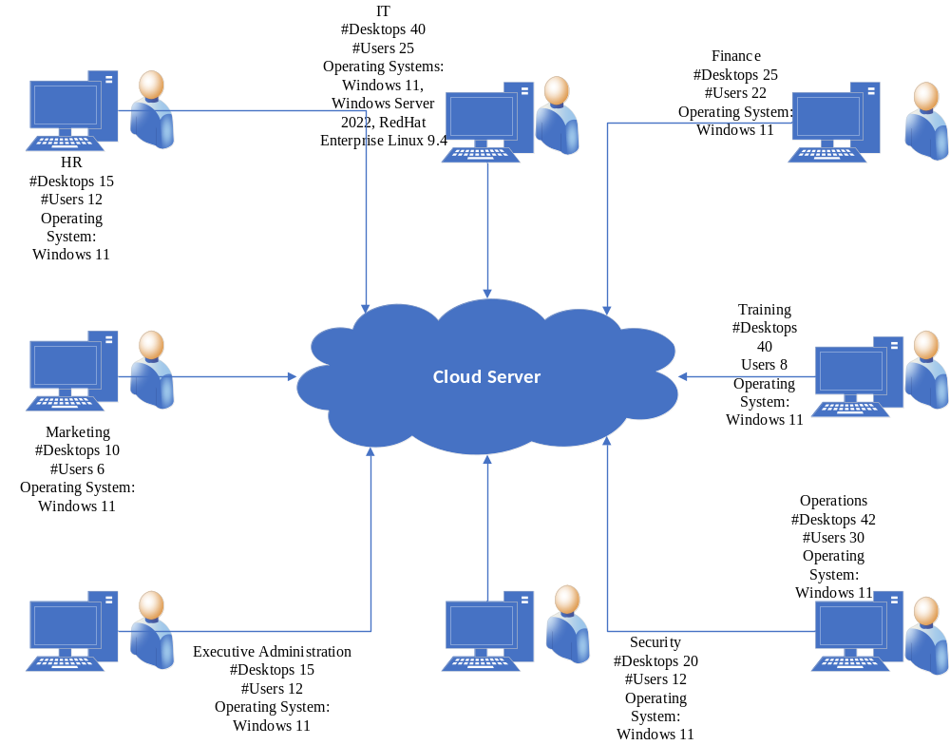

It is paramount for the organization’s desktop systems to be brought up to date for long-term software and security updates. 101 Windows 7 desktops have to be upgraded to Windows 11-supported hardware. The OS should be cloud-based so that remote workers can interact with those within the offices. This transition will be the most difficult as the IT, HR, Marketing, Executive Administration, Security, Operations, Training, and Finance departments use Windows 7 equipment. The best time to make this transition would be over the weekend. This allows the IT department to switch the organization to the new hardware in one go, instead of slowly replacing each department's desktops.

The 6 Windows Server 2012 R2 desktops would have an easier transition. The OS should be cloud-based for quick communication with other Windows users working remotely. Since these desktops are all in the IT department the upgrade to Windows 2022 compatible hardware will be much simpler. IT technicians can work on replacing these six server desktops simultaneously.

The 7 macOS El Capitan desktops have to be replaced with Windows 11 devices. The El Capitan operating system will be a decade old in 2025. It no longer receives security updates and the MacBooks running it are considered obsolete. These 7 desktops will need to be replaced with modern hardware. The training and marketing departments must share the same type of hardware as other departments. This will help mitigate the problem of onboarding an employee who uses a Mac to a Windows desktop and vice versa. The OS should be cloud-based to prioritize remote work and align with the rest of the organization.
13 Linux RedHat desktops will need to be updated to RedHat Enterprise Linux 9.4. This operating system is the latest version of RedHat available. The OS should be cloud-based to prioritize the virtualization of software. This will help lower costs since the IT department prioritizes the Windows operating system. Spending more money than necessary on a small section of a department doesn’t make sense when it could perform just as efficiently using a cloud-based OS.

